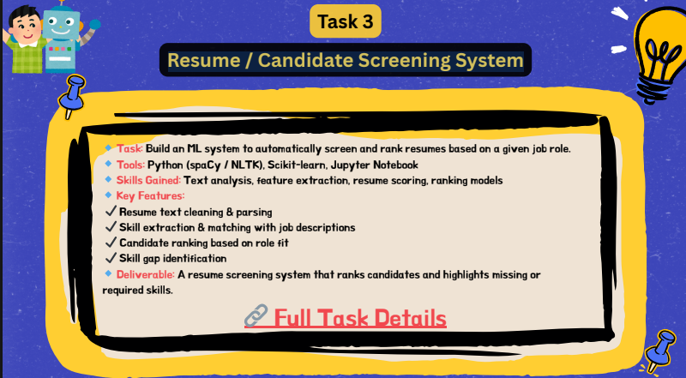
TOPICS
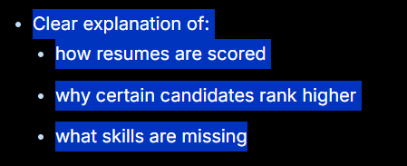
Model preview:
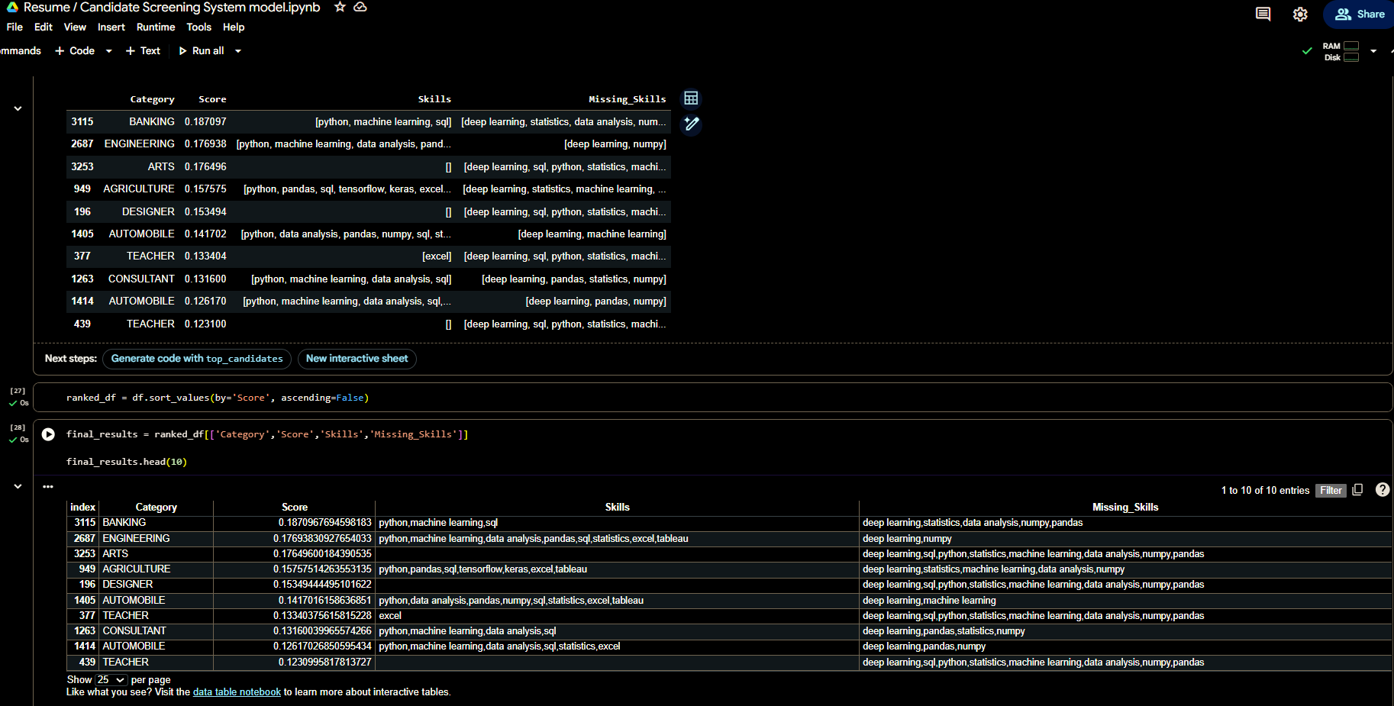
View here : Screening System Modelscreening system model
- how resumes are scored
The resumes are scored using a text similarity method between the resume content and the job description.
First, all resumes and the job description are cleaned and converted into a structured format by removing unnecessary words and symbols.
Then, TF-IDF Vectorization converts text into numerical values based on word importance.
After that, Cosine Similarity is used to compare each resume with the job description.
The similarity score ranges between 0 and 1:
- Score closer to 1 → Strong match
- Score closer to 0 → Weak match
Example:
Candidate | Score | Meaning
Candidate A | 0.82 | Strong match
Candidate B | 0.45 | Moderate match
Candidate C | 0.12 | Poor match
Higher score means the resume contains more relevant skills and keywords related to the role.
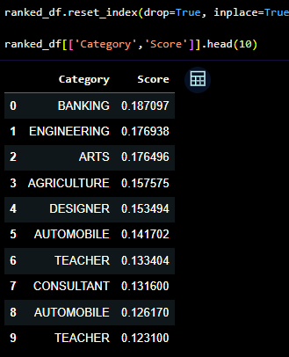

2.Why Certain Candidates Rank Higher
Candidates rank higher because their resumes contain more relevant skills and keywords that match the job description.
For example, a candidate with skills like:
- Python
- Machine Learning
- Pandas
- Data Analysis
- SQL
will receive a higher score because these skills appear in the job description.
Candidates with unrelated skills such as:
- HR Management
- Recruitment
- Payroll
receive lower scores because their skills do not match the Machine Learning Intern role.
The ranking system ensures that the most suitable candidates appear at the top.

3. What Skills Are Missing
The system compares the required skills from the job description with the skills found in each resume.
Missing skills are calculated as:
Missing Skills = Job Skills − Candidate Skills
Example:
Job Required Skills:
- Python
- Machine Learning
- Pandas
- SQL
- Deep Learning
Candidate Skills:
- Python
- Pandas
Missing Skills:
- Machine Learning
- SQL
- Deep Learning
This helps recruiters understand:
- Which candidates need improvement
- Which candidates are job-ready
- What training may be required

